If you or someone else is in immediate danger, call the police on 999.
If you need urgent help with your mental health, please either:
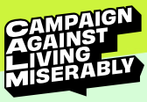
- Contact your local GP surgery
- Call the NHS on 111
- Call Samaritans on 116 123
- Text SHOUT to 85258 to start a free confidential conversation (24/7)
- Contact CALM on their national helpline: 0800 58 58 58 (5pm – midnight)
- Call the Coventry and Warwickshire Partnership NHS Trust: 0300 200 0011 (free 24/7)
For VAWG related support services in Warwickshire please use this website: https://www.talk2someone.org.uk

Here are a range of other services that can help to provide someone with support and advice:

SUPPORT SERVICES FOR VICTIMS OF CRIME
Victim Support https://www.victimsupport.org.uk
Provides emotional and practical help to victims or witnesses of any crime, whether or not it has been reported to the police.
Phone: 0808 16 89 111 (24/7)
Warwickshire: 01926 358060 (Mon-Fri 9am – 5pm)
Crime Stoppers https://crimestoppers-uk.org
Report crime anonymously.
Phone: 0800 555111
SupportLine https://www.supportline.org.uk
Offer confidential emotional support to children, young adults and adults. Work to develop healthy, positive coping strategies, an inner feeling of strength and increased self-esteem to encourage healing, recovery and moving forward.
Phone: 01708 765200
The National Association for People Abused in Childhood https://napac.org.uk  Support, advice, and guidance to adult survivors of any form of childhood abuse.  Phone: 0808 801 0331 | 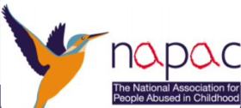
Help for Adult Victims of Child Abuse www.havoca.org
Run by survivors for adult survivors of child abuse. Havoca provide support, friendship, and advice for any adult whose life has been affected.
Modern Slavery https://www.modernslaveryhelpline.org
Get help, report a suspicion, or seek advice.
Phone: 08000 121 700
Support after Murder and Manslaughter https://www.samm.org.uk
Offers understanding and support to families and friends who have been bereaved as a result of murder or manslaughter, through the mutual support of others who have suffered a similar tragedy.
Phone: 0845 8723440

SUPPORT SERVICES FOR SURVIVORS OF SEXUAL ABUSE, ASSAULT AND VIOLENCE
RoSA https://rosasupport.org  Provides support for survivors of rape, sexual abuse, sexual exploitation, and sexual violence in Warwickshire.  Phone: 01788 551151 Email: support@rosasupport.org | 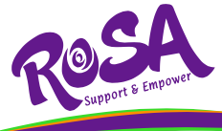
The Blue Sky Centre – Warwickshire SARC https://blueskycentre.org.uk
Sexual assault referral centres offer medical, practical, and emotional support to anyone who has been sexually assaulted or raped. They have specially trained to paediatricians / Forensic Nurse Examiners, and support workers to care for you.
Phone: 0800 970 0370
Survivors Trust https://www.thesurvivorstrust.org  Provide support and signposting for women, men and children who are survivors of rape, sexual violence, or childhood sexual abuse.  Phone: 0808 801 0818 Email: info@thesurvivorstrust.org | 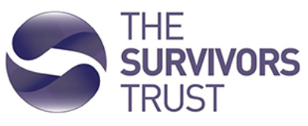
Rape Crisis England & Wales https://rapecrisis.org.uk
Confidential support and information to women in England and Wales who have survived any form of sexual violence, no matter how long ago. Also provides immediate support to friends and family on how to support female survivors of sexual violence.
Phone: 0808 802 9999 (12pm – 2:30pm & 7pm – 9:30pm daily)
Cis’ters http://cisters.org.uk/
Survivor led group for women who, as female children/teens, were raped/sexually abused by a member of their immediate/extended family.
Phone: 023 80 338080 Email: helpme@cisters.org.uk
Survivors UK https://www.survivorsuk.org
Help sexually abused men as well as their friends and family, no matter when the abuse happened, and challenge the silence and attitudes.
Phone: 02035983898 Email: help@survivorsuk.org
Safeline https://www.safeline.org.uk
Provides support and counselling for male survivors of sexual abuse or rape.
Phone: 0808 8005005

DOMESTIC ABUSE SUPPORT SERVICES
Talk2Someone Warwickshire https://www.talk2someone.org.uk
Support for those experiencing abuse in Warwickshire.
Phone: 0800 408 1552
Women's Aid https://www.womensaid.org.uk  Provides practical support and information for women experiencing domestic violence via the Survivor's Handbook and local services.  Email: Phone@womensaid.org.uk | 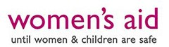
Refuge https://www.refuge.org.uk/our-work/our-services/refuge-warwickshire-domestic-violence-service/
Safe, emergency accommodation and emotional and practical support to women and children experiencing domestic abuse.
National Domestic Abuse Phone: 0808 200 247
The ManKind Initiative https://www.mankind.org.uk
Confidential help and support for male victims of domestic abuse.
Phone: 01823 334244 (Mon-Fri 10am – 4pm)
Galop http://www.galop.org.uk  Provides support to LGBT people suffering domestic abuse.  Phone: 0800 999 5428 | 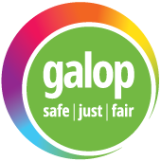
The SHARAN Project https://sharan.org.uk
Support and advice for vulnerable women, particularly of South Asian origin, who have left home forcefully or voluntarily as a result of disownment; threat of domestic or honour-based violence; forced marriage or other forms of cultural conflict.
Phone: 0844 504 3231
Karma Nirvana https://karmanirvana.org.uk
Supports victims and survivors of Forced Marriage and Honour Based Abuse.
Phone: 0800 5999 247
The Forced Marriage Unit https://www.gov.uk/stop-forced-marriage
If you or someone you know is at risk of a forced marriage, please contact 0207 008 0151 from 9am – 5pm between Mon-Fri, or 0207 008 1500 outside these hours.

SUBSTANCE MISUSE SUPPORT SERVICES
Change Grow Live
https://www.changegrowlive.org/drug-alcohol-service-warwickshire
Change Grow Live Warwickshire is a free and confidential drug and alcohol service.
Leamington Spa: 16 Court Street, Leamington Spa, Warwickshire, CV31 2BB
Nuneaton: 112 Abbey Street, Nuneaton, Warwickshire, CV11 5BX
Rugby: 35-37 Albert Street, Rugby, Warwickshire, CV21 2SG
Phone: 01926 353 513 Email: Warwickshire.Info@cgl.org.uk
Compass https://www.compass-uk.org/services/warwickshire-cypdas/  A free, confidential substance misuse service for children and young people who need support around their own or another person’s drug or alcohol use. The service works with anyone between 5 and 25 years of age in Warwickshire.  ChatHealth confidential text messaging: 07507 331 525  Phone: 01788 578 227 Email: compass.warksypsduty@nhs.net | 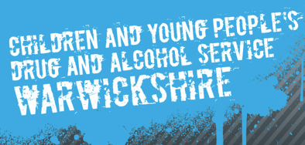
Alcoholics Anonymous https://www.alcoholics-anonymous.org.uk  Provides opportunities to share experience, strength and hope to recover from alcoholism.  Phone: 0800 9177 650 Email: help@aamail.org | 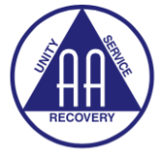
Narcotics Anonymous https://ukna.org
Non-profit fellowship or society of people for whom drugs had become a major problem, uses a traditional 12-step model.
Phone: 0300 999 1212 (10am – midnight)
Cocaine Anonymous https://cocaineanonymous.org.uk  Provides opportunities to share experience, strength and hope to recover from addiction to cocaine and all other mind-altering substances.  Phone: 0800 612 0225 | 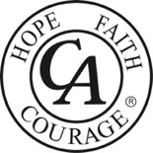
SMART Recovery https://www.smartrecovery.org
Mutual support for anyone seeking science-based, self-empowered addiction recovery.
FRANK http://www.talktofrank.com
Provides a confidential service to anyone wanting information, advice, or support about any aspect of drugs.
Phone: 0300 123 6600 + Online chat facility (2pm-6pm weekdays)
Port of Call https://portofcall.com/
Helping people overcome addiction and find rehab.
Phone: 0808 271 8965
Addiction Helper http://www.addictionhelper.com/  UK’s leading addiction resource website.  Phone: 0800 024 1455 | 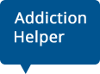
We Are With You https://www.wearewithyou.org.uk
We Are With You has services throughout England that help adults, young people, and their families recover from addiction and substance misuse problems.
Drinkline
Confidential support for those worried about their own or someone else's drinking. Can put you in touch with local support.
Phone: 0300 123 1110 (weekdays 9am – 8pm, weekends 11am – 4pm)

SUPPORT SERVICES FOR YOUNG PEOPLE AND THEIR FAMILIES
Barnardos https://www.barnardos.org.uk/what-we-do/services/warwickshire-base-service  Provide a range of services to help and support families across the UK, working with organisations and professionals so that children get the best start in life.  Phone: 0208 550 8822  Barnardos Beacon Service  Barnardos have launched a service to support young people 0-19 who have been sexually abused and who live in Warwickshire or the West Midlands. The service will work with young people, their parents/carers and a wide range of professionals to help young people cope and recover from sexual abuse. | 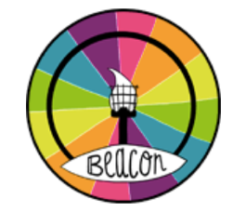
Something’s Not Right https://www.somethingsnotright.co.uk/index.php?u=3
Support for Child Exploitation in Warwickshire
Childline https://www.childline.org.uk
Free, 24-hour confidential Phone for children and young people who need to talk.
Phone: 0800 1111
NSPCC https://www.nspcc.org.uk
Provides help, advice and support to adults worried about a child.
Phone: 0808 800 5000 (24/7)
YoungMinds https://youngminds.org.uk
Offers information, support and advice for children and young people. Help for concerned parents of those under 25 is offered by phone.
Phone: 0808 802 5544 (Mon-Fri 9.30am – 4pm)
Youth Access http://www.youthaccess.org.uk/  Find free and confidential counselling, advice, and information services.  Phone: 020 8772 9900 | 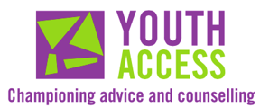
HOPELineUK https://papyrus-uk.org
Offers support, practical advice and information to young people considering suicide and can also offer help and advice if you’re concerned about someone you know.
Phone: 0800 068 41 41
The Mix https://www.themix.org.uk
Provides non-judgmental support and information for young people under 25 on everything from sex and exam stress to debt and drugs and self-harm.
Phone: 0808 808 4994
Nightlines https://www.nightline.ac.uk/want-to-talk/
Confidential, anonymous, non-judgemental support services run by students for students. Search for your local Nightline details via the website.
Pace http://paceuk.info  Parents Against Child Sexual Exploitation works alongside parents and carers of children who are – or are at risk of being – sexually exploited.  Phone: 0113 240 5226 | 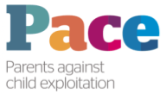
MOSAC http://www.mosac.org.uk/
Provides supportive services in a safe, non-judgemental environment for non-abusing parents and carers whose children have been sexually abused.
Phone: 0800 980 1958
Stop it Now www.stopitnow.org.uk  Helping prevent child sexual abuse.  Phone: 0808 1000 900 | 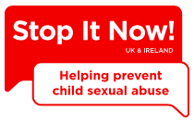

MENTAL HEALTH SUPPORT SERVICES
Mind https://www.mind.org.uk
Provides advice and support on a range of topics including types of mental health problem, legislation and details of local help and support in England and Wales.
Phone: 0300 123 3393 (Mon-Fri 9am – 6pm)
Herefordshire Phone: 01432 271643
Herefordshire Email: info@herefordshire-mind.org.uk
British Association of Counselling and Psychotherapy www.bacp.co.uk
Looking for counselling for yourself or someone else? bacp can help!
British Association of Behavioural and Cognitive Psychotherapies  www.babcp.co.uk Find an accredited CBT therapist.  Phone: 0330 320 0851 Email: babcp@bapcp.com | 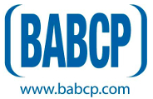
Counselling Directory www.counselling-directory.org.uk/
Find a counsellor or therapist near you.
Phone: 033 325 2500
Rethink Mental Illness https://www.rethink.org/advice-and-information/
Offers practical help and information to anyone affected by mental illness on a wide range of topics such as the Mental Health Act, living with mental illness, etc.
Phone: 0300 5000 927 (Mon-Fri 9.30am – 4pm)
Harmless http://www.harmless.org.uk
Provides a range of services about self-harm including support,
information to people who self-harm, their friends and families.
SANE http://www.sane.org.uk
Provides confidential emotional support and information to anyone affected by mental illness. It also provides a resource for anyone affected by suicide.
Phone: 0300 304 7000 (4.30pm – 10.30pm daily)
The Big White Wall www.bigwhitewall.com
Anonymous community where members can support each other 24/7.
ASSIST Trauma Care http://assisttraumacare.org.uk  Information and specialist help for people with PTSD and anyone supporting them.  Phone: 0178 856 0800 | 